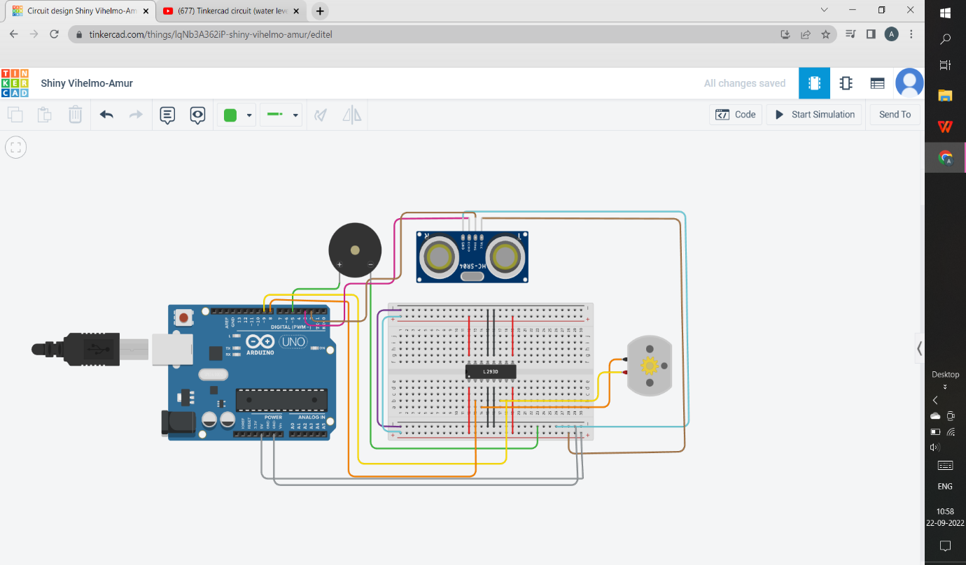

COMPOENTS:

* ULTRASONIC DISTANCE SENSOR
* PIEZO
* DC MOTOR
* H-BRIDGE MOTOR DRIVER
* BREADBOARD SMALL
* ARDUINO UNO R3

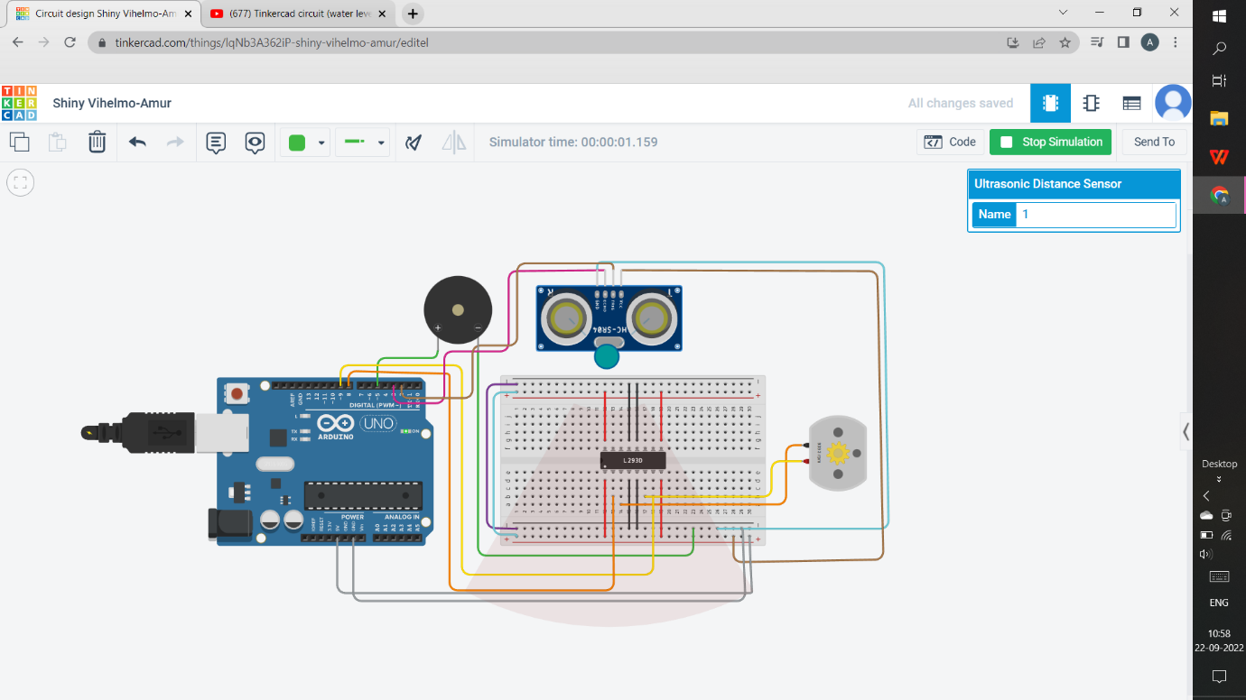

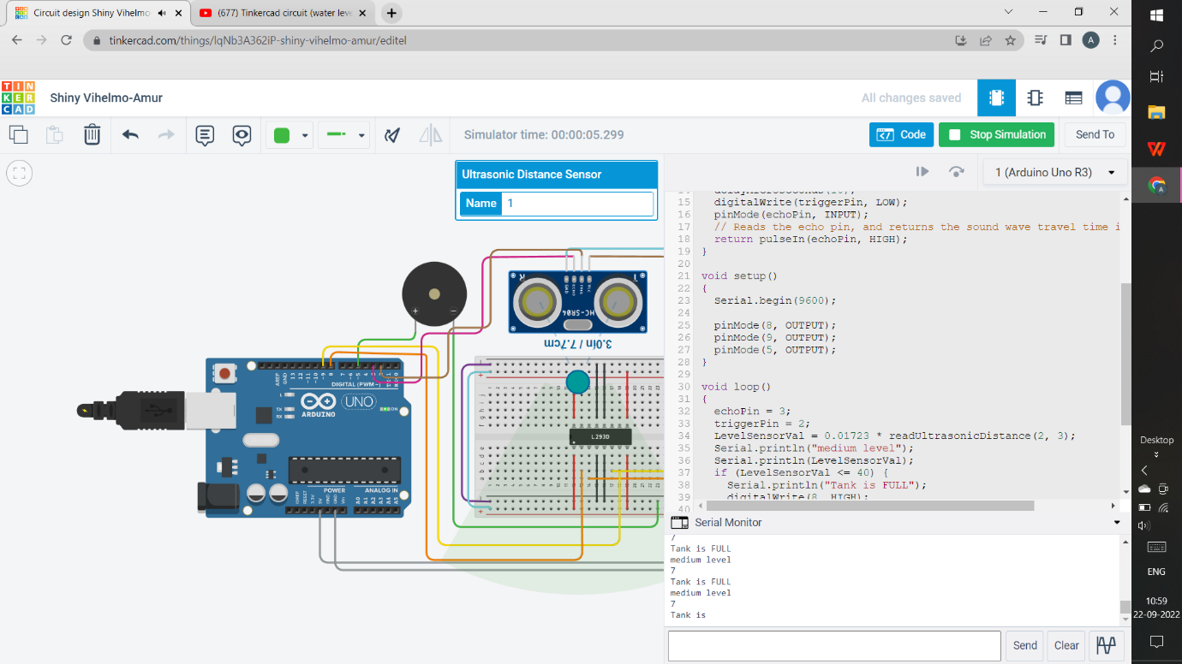

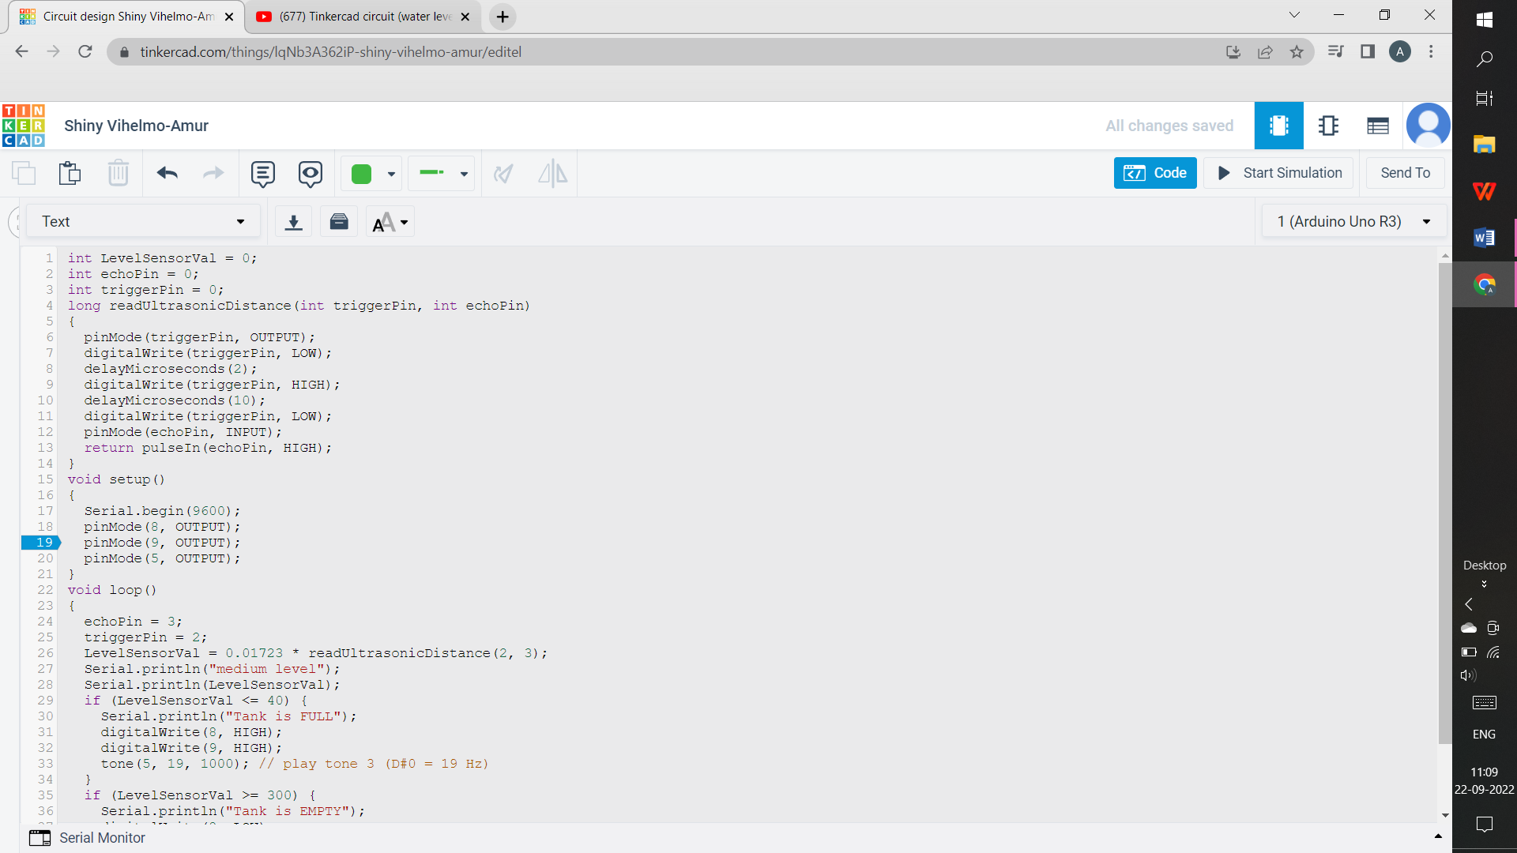

**CODING:**

int LevelSensorVal = 0;

int echoPin = 0;

int triggerPin = 0;

long readUltrasonicDistance(int triggerPin, int echoPin)

{

pinMode(triggerPin, OUTPUT);

digitalWrite(triggerPin, LOW);

delayMicroseconds(2);

digitalWrite(triggerPin, HIGH);

delayMicroseconds(10);

digitalWrite(triggerPin, LOW);

pinMode(echoPin, INPUT);

return pulseIn(echoPin, HIGH);

}

void setup()

{

Serial.begin(9600);

pinMode(8, OUTPUT);

pinMode(9, OUTPUT);

pinMode(5, OUTPUT);

}

void loop()

{

echoPin = 3;

triggerPin = 2;

LevelSensorVal = 0.01723 * readUltrasonicDistance(2, 3);

Serial.println("medium level");

Serial.println(LevelSensorVal);

if (LevelSensorVal <= 40) {

Serial.println("Tank is FULL");

digitalWrite(8, HIGH);

digitalWrite(9, HIGH);

tone(5, 19, 1000); // play tone 3 (D#0 = 19 Hz)

}

if (LevelSensorVal >= 300) {

Serial.println("Tank is EMPTY");

digitalWrite(8, LOW);

digitalWrite(9, HIGH);

}

delay(10); // Delay a little bit to improve simulation performance

}